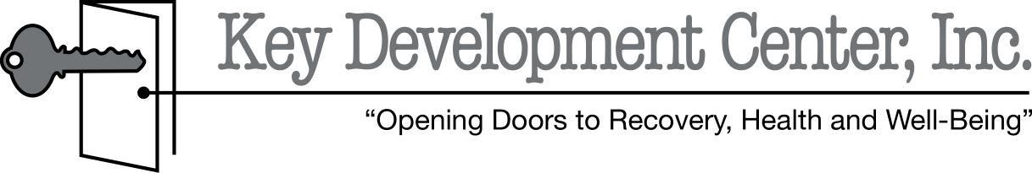
REQUEST FOR INTERNAL REVIEW/LOCAL APPEAL
Instructions to the requestor:
1. Please complete the form below. Assistance is available by calling your local Appeals Officer, Customer Services, or your local Office of Recipient Rights at 810-220-8192
2. You must file an Internal Appeal of the Adverse Benefit Determination prior to filing an appeal with the Michigan Office of Administrative Hearings and Rules (MOAHR).
3. You must file for your Internal Appeal within 60 days of this Adverse Benefit Determination.
4. The review and decision will occur within thirty (30) days.
5. You will receive written notification of the decision of the local appeals committee and subsequent avenues if you are not satisfied with the results.
6. After you have completed this form, please mail it to:

Key Development Center, Inc.
2060 Grand River Annex, Suite 600
Brighton, MI 48114

ATTN: Lisa Boschma
To be completed by the requestor:
I WANT TO REQUEST A REVIEW OF MY APPEAL. Here are my reasons for this request:

_________________________________ ________________ _________________________________
Your Signature Date Your Name

Your Address: ________________________________________________________________________ __________________________________________________________________________________________
Your Telephone Number: _______________________________________________________________
You may represent yourself or have anyone you would like represent you. If you want someone else to represent you at the internal appeal, called an Authorized Hearing Representative (AHR), please complete their contact information below. You can still be involved and present at the appeal if you have an AHR.
Name of Representative |  |  | Representative Telephone Number  ( )
Address (No. & Street, Apt. No.) |  |  | Representative Signature | Date Signed
City | State | ZIP Code | Relationship to Client:

